Algebra 1:
Unit #5: Functions Reflective Portfolio
At the conclusion of each unit, you will complete a reflective study sheet.
Section #1: Vocabulary: Write a definition for each
- Domain vs Range:

- Function:

Section #2: Formulas/Equations/Rules (Show the process)
- The name of seven parent functions:

- The formula for finding the average rate of change.

Section #3: Key methods and concepts
- Identify if the relation represents a function and justify your answer. 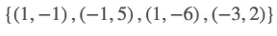
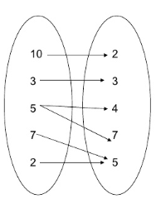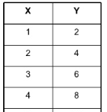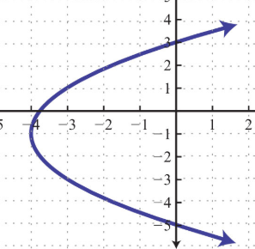

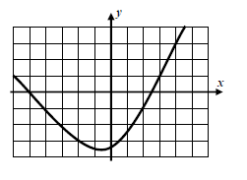
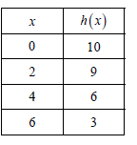
- Given the following three functions: x f(x)
3

6
-1

0

2
t(x) h(x)

- Evaluate t(3)= ________ h(4)= ________ f(-1)= __________ -2f(-1)+3t(3)=

- Find x when $t\left(x\right)=-1$ ____________ Find x when $h(x)=10$ ___________

- Find the Average rate of change over the interval 2≤x≤4 for t(x) and h(x)

- Look at the graph and find the following
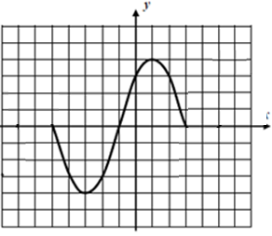
- Domain:__________________

- Range:______________________

- Intercepts. Zeros:_________________________________

y-intercept___________________________

- Intervals An increasing interval____________________________
A decreasing interval____________________________
An interval where f(x) > 0______________________
An interval where f(x)< 0________________________

- Extrema: Maximum:______________________________ Minimum:_____________________________

- Graph the following step function:
$$h\left(t\right)=\left\{\begin{aligned}3 0≤t≤2 \\ 6 2<t≤5 \\ 8 5<t≤12\end{aligned}\right.$$

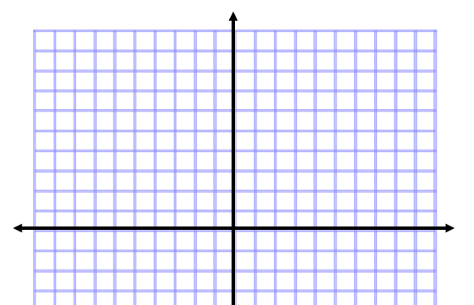
- Graph and evaluate the following Piecewise function
$f\left(x\right)=\left\{\begin{aligned}x+3 x<-2 \\ x^{2} -2≤x<1 \\ -x+2 x≥1\end{aligned}\right.$

- Evaluate based on the above h(t) and f(x)
f(-2)= f(1)=
h(1)= h(5)=

